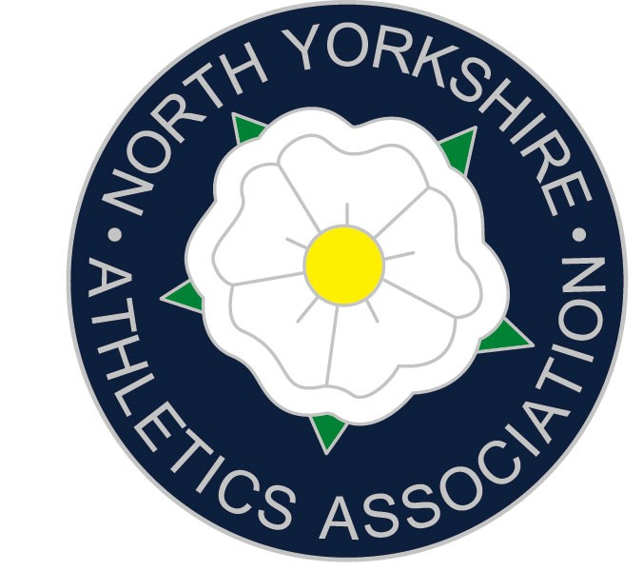
Dear Headteacher June 2022

It gives me great pleasure to inform you that the above named student has been selected to represent North Yorkshire at the English Schools Track & Field Athletics Championships on the 8th & 9th July at Manchester.
They are one of only 40 students to be selected from all the schools in North Yorkshire. I am sure that you will agree what a fantastic achievement this is.

Athletes will travel to Manchester by coach on the Thursday afternoon/evening. They will need to miss school on the Thursday afternoon, to meet the bus, and on the Friday to compete. I have no doubt that you will grant permission for this absence as an approved sporting activity.

The cost of the trip is £135. Parents have been asked to pay this. However, some schools in the past have reimbursed some or all of this cost.

I am sure that you will now contact your student and congratulate them on being selected to attend this prestigious event. They will also be awarded their County Colours for competing in the Championships. Athletes can purchase a tie and a pin badge as well as items of clothing including a county vest.

I would be extremely grateful if you would also show this letter to your Head of Physical Education.

Yours faithfully

Andrew Rickard
Chairman of North Yorkshire Schools Athletics Association
Thirsk School & Sixth Form College

Thirsk School & Sixth Form College
Topcliffe Road
Thirsk
YO71RZ
01845 522024 andrew.rickard@thirskschool.org andrew.rickard@nysaa.org.uk

