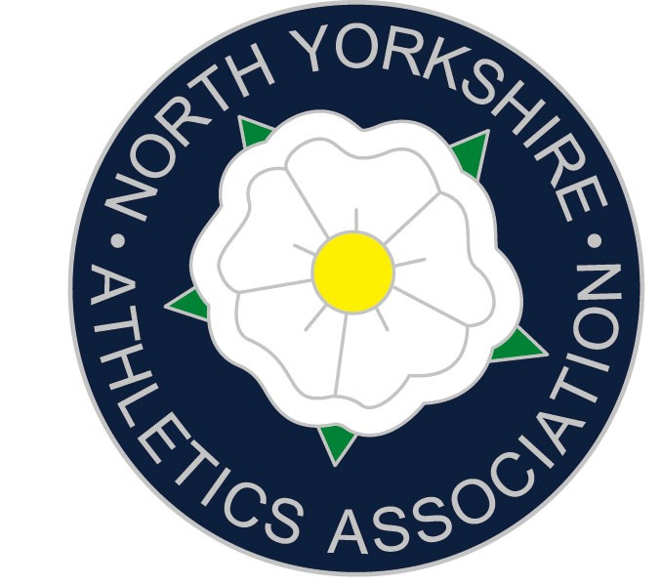

Congratulations, you have been selected to represent North Yorkshire at the English Schools Track & Field Championships. These will be held at the Etihad Stadium Manchester on Friday 8th and Saturday 9th July 2022.

Travel

You will be expected to travel on the team coach on Thursday 7th July. The team coach will return on Saturday night, but you are welcome to travel back with parents on the Saturday if you wish. Obviously, team managers need to be informed about those leaving the Championships with parents once the parade has finished.

YOU MUST NOT LEAVE THE CHAMPIONSHIPS UNTIL AFTER THE PARADE ON THE SATURDAY AFTERNOON EVEN IF YOU ARE ONLY COMPETING ON THE FRIDAY.

Accommodation & Food

During the weekend the team will be staying all together in hotel accommodation in the Manchester area. Breakfast and evening meals will be provided. Athletes will need to provide all other meals including food for the journey to and from Birmingham and lunch on both days. If you have special dietary requirements, then please let me know on the reply sheet.

Kit

You will need a county vest to compete in which we can lend out if you do not have one. You will also need to take your own PLAIN BLACK ATHLETICS SHORTS and extra clothing for all weathers! (DO NOT BRING ¾ LENGTH SHORTS, GIRLS MAY WEAR RUNNING KNICKERS BUT MUST BE PLAIN BLACK. FAILURE TO WEAR THE CORRECT KIT MAY RESULT IN DISQUALIFICATION!) No multi coloured tights or cropped bra tops can be worn. Examples of what is NOT allowed are shown on the ESAA.net website. We always enter relay teams so if you are in a field event you may be considered and must bring your running spikes with you. Also bring 8 pins. It is extremely important that athletes wear their team kit at all times throughout the event.

If you would like to purchase additional kit, then click the link: www.nysaa.org.uk/kit/
Once you have decided what you would like then please email Andy at andrew.rickard@nysaa.org.uk letting him know what you would like to purchase. State the items(s) and size(s). Andy will email you back to confirm and let you know how to pay.

Behaviour

Being selected for your county is an honour and a result of all your hard training, please remember this throughout the weekend and set a good example always. If there is a serious misbehaviour, then it is possible that an athlete may be sent home.

Equipment

Your own throwing implements can be taken (maximum two); please ensure that they are insured. All throwing implements will need to be approved by the Field Referee. The time slots for this will be discussed on the first evening. However, throwing implements will be provided. Starting blocks will be provided for those events where they are permitted and only these starting blocks will be permitted. The maximum length spike is 6mm on the track and 9mm elsewhere on the field.

False Starts

In Senior races athletes will be disqualified after one false start, Inters and Juniors after two.

GDPR

Please note that the ESAA is compliant with the GDPR (General Data Protection Regulations) and that entry details we and the ESAA collect are only for the purpose of gaining the information required for entry to the national school’s championships and will only be held as long as it is being used for that purpose. However, athletes should be reminded that photographs and video will be taken by ESAA and other photographers, as well as live streaming and that, if athletes are not willing for these to be published on the ESAA website, facebook page and other social media, they should turn down their selection for the county, as there is no way to differentiate when photos and videos are taken.

Cost and Kit payment

The county can cover most of the expenses, but you are asked to contribute £135 towards the costs. This does include a team t shirt. Schools have assisted with this cost in the past, I suggest you ask.

Please make one payment of the £135.
Two payment methods below.

Sort Code: 77-56-13 Acc. No.: 08825060 Lloyds Bank
State the athlete’s name in the reference box.

Cheques payable to: “North Yorkshire Schools Athletics Association”
Posted to: Andrew Rickard 1, Station Drive, Ripon HG4 1JA

If your school requires an invoice we can send them on, ask them to email Andy.

It is extremely imperative that all athletes are fully fit and able to participate, therefore if this is not the case, I would very much appreciate being informed prior to the event so that a replacement can be sought.

The full North Yorkshire team will be available on our website www.nysaa.org.uk
There is a section on the ESAA website entitled “Notes for Parents” which can be found in the Reference section.

Finally, can I congratulate you on your selection and ask you to ensure that the registrations are completed immediately and that you order any kit via email to Andrew at the very latest by Saturday 25th June. Train hard, stay free from injury and contact me if there are any further questions.

Please print off the accompanying letter and pass to your Head teacher and inform your Head of PE of your selection.

Transport Saturday 9th July
Thursday 7th July Down Return (approx)
Aireville Park (swimming Pool) 1.15pm 8.30pm
King James’s Knaresborough 2.15pm 7.45pm
Wetherby Services 3.00pm 7.00pm
Ferrybridge Services 3.30pm 6.30pm
Manchester 5.00pm 5.00pm

Emergency contacts during the trip – Adam Milner 07835447424
Andrew Rickard 07736547907

Now you have read all the information could I please ask that you click this link and complete the North Yorkshire registration form: http://www.nysaa.org.uk/championships/

You must also complete the athlete registration, https://forms.office.com/r/wMtn4jE2ggif
if you have not already done so

If you have any questions/queries it is imperative you ask them.

Adam Milner
NYSAA Track and Field Team Manager

Tel: 07835447424 milnera@ripongrammar.com

