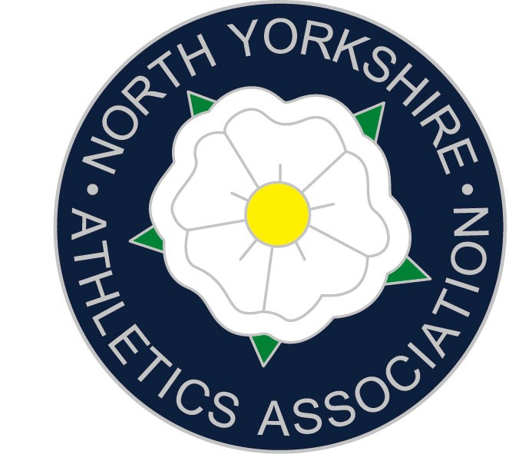

Congratulations, you have been selected to represent North Yorkshire at the English Schools Track & Field Championships. These will be held at the Alexander Stadium on Friday 11th and Saturday 12th July 2025.

https://forms.office.com/r/wMtn4jE2gg - Please complete this form, urgently!

Travel
You will be expected to travel on the team coach on Thursday 10th July. The team coach will return on Saturday night, but you are welcome to travel back with parents on the Saturday if you wish. Obviously, team managers need to be informed about those leaving the Championships with parents once the parade has finished.

YOU MUST NOT LEAVE THE CHAMPIONSHIPS UNTIL AFTER THE PARADE ON THE SATURDAY AFTERNOON EVEN IF YOU ARE ONLY COMPETING ON THE FRIDAY.

Accommodation & Food
During the weekend the team will be staying all together in hotel accommodation in the Birmingham area. Breakfast and evening meals will be provided. Athletes will need to provide all other meals including food for the journey to and from Birmingham and lunch on both days. If you have special dietary requirements, then you should have already notified me via the form, please let me know by email if not.

Kit
You will need a county vest to compete in which we can lend out if you do not have one. You will also need to take your own PLAIN BLACK ATHLETICS SHORTS and extra clothing for all weathers! (DO NOT BRING ¾ LENGTH SHORTS, GIRLS MAY WEAR RUNNING KNICKERS BUT MUST BE PLAIN BLACK. FAILURE TO WEAR THE CORRECT KIT MAY RESULT IN DISQUALIFICATION!) No multi coloured tights or cropped bra tops can be worn. Examples of what is NOT allowed are shown on the ESAA website. Also bring 8 pins. It is extremely important that athletes always wear their team kit throughout the event.

As part of your payment, you will be given a North Yorkshire training t-shirt. If you would like to purchase additional kit, then click this link (order asap so it arrives in time):
https://halbro.com/product-category/your-store/nysaa/

Behaviour
Being selected for your county is an honour and a result of all your hard training, please remember this throughout the weekend and set a good example always. If there is a serious misbehaviour, then it is possible that an athlete may be sent home.

Equipment
Your own throwing implements can be taken (maximum two); please ensure that they are insured. All throwing implements will need to be approved by the Field Referee. The time slots for this will be discussed on the first evening. However, throwing implements will be provided. Starting blocks will be provided for those events where they are permitted and only these starting blocks will be permitted. The maximum length spike is 6mm on the track and 9mm elsewhere on the field.

False Starts
In Senior races athletes will be disqualified after one false start, Inters and Juniors after two.

GDPR
Please note that the ESAA is compliant with the GDPR (General Data Protection Regulations) and that entry details we and the ESAA collect are only for the purpose of gaining the information required for entry to the national school’s championships and will only be held if it is being used for that purpose. However, athletes should be reminded that photographs and video will be taken by ESAA and other photographers, as well as live streaming and that, if athletes are not willing for these to be published on the ESAA website, Facebook page and other social media, they should turn down their selection for the county, as there is no way to differentiate when photos and videos are taken.

A note from ESAA
‘All entrants shall be deemed to have made him/herself/themselves familiar with and agreed to be bound by the UKA Anti-Doping Rules and to submit to the authority of UK Anti-Doping in the application and enforcement of the Anti-Doping Rules.
The UKA Anti-Doping Rules apply to entrants participating in the sport of Athletics, for 12 months from the date of entry, whether, or not the entrant is a citizen of, or resident in, the UK.’

Cost and Kit payment
The county can cover most of the expenses, but you are asked to contribute £195 towards the costs. This does include a team t shirt. Schools have assisted with this cost in the past, I suggest you ask Headteacher and/or Heads of PE. Attached is a letter to hand to your headteacher, any questions or requests regarding invoices etc please send these direct to the treasurer Alastair Scholey at alastair.scholey@nysaa.org.uk

Please make one payment of £195
Payment method below.
Lloyds Bank
Sort Code: 77-56-13 Acc. No.: 08825060
North Yorkshire School’s Athletics Association.
State the athlete’s name in the reference box.

Transport Saturday 13th July
Thursday 11th July Down Return (approx)
Giggleswick 11.00am 10.15pm
Aireville Park (swimming Pool) 11.30am 9.45pm
King James’s Knaresborough 12.30pm 8.45pm
Wetherby Services 1.00pm 8.15pm
Birmingham 4.00pm 5.30pm

Emergency contacts during the trip – Adam Milner 07835447424
Andrew Rickard 07736547907

It is extremely important that all athletes are fully fit and able to participate, therefore if this is not the case, I would very much appreciate being informed prior to the event so that a replacement can be sought.

If you have any questions/queries, please get in touch.

Adam Milner
NYSAA Track and Field Team Manager
Tel: 07835447424 adam.milner@nysaa.org.uk

A note from ESAA

‘All entrants shall be deemed to have made him/herself/themselves familiar with and agreed to be bound by the UKA Anti-Doping Rules and to submit to the authority of UK Anti-Doping in the application and enforcement of the Anti-Doping Rules.

The UKA Anti-Doping Rules apply to entrants participating in the sport of Athletics, for 12 months from the date of entry, whether, or not the entrant is a citizen of, or resident in, the UK.’

