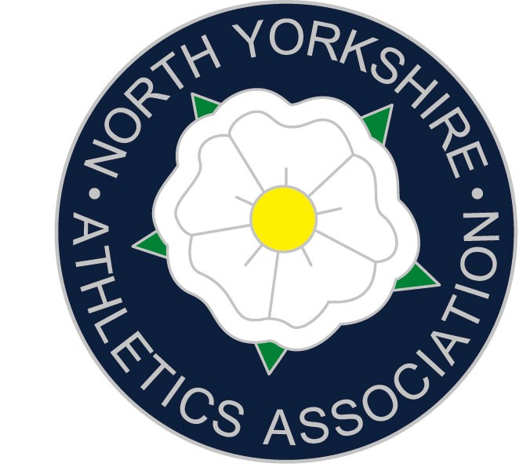


North Yorkshire Schools Athletics Association
Track and Field Team selection

Dear Athlete (& Parent) Saturday 14th June 2025
Congratulations on your performance today, you have finished in the top 3 in your event and may now be considered for selection to represent NYSAA. Selection at the following events differs depending upon your age group and finishing position today. Please read the selection details carefully.

NORTHERN INTER-COUNTIES
Juniors (Yrs 8 & 9), Inters (Yrs 10 & 11), possibly some seniors (Yrs12 & 13)

If you have finished in the top 2 places today in Juniors and Inters events, you are now invited to represent NYSAA against the Northern Counties (Cleveland / Cumbria / Durham / Northumberland) at Middlesbrough Sport Village, on Saturday 21st June 2025. All athletes selected because of today’s Champs are strongly encouraged to compete at Middlesbrough as this will entitle you to a county vest and tie which can be purchased. Please bring cash on the day, vests are £30 and ties £15. We do have a small number of older vests we can loan out on the day. It is also another opportunity to try to attain the standard for the ESAA Nationals against better opposition. The programme of events is attached and available on our website. Athletes who finished third, you are first reserve for this event and should still complete the form below so you can be called up if required. Please note athletes/parents must provide their own transport to this event. On the day of the event athletes should report to NYSAA team managers near the finish line at least one hour before their event to register and collect numbers. If a senior wishes to compete they must contact me directly with the request, using the email below.
ENGLISH SCHOOLS (ESAA) TRACK AND FIELD CHAMPIONSHIPS
Juniors (Yrs 8 & 9), Inters (Yrs 10 & 11), Seniors (Yrs12 & 13)

The ESAA Nationals take place at Alexander Stadium, Birmingham on 11th & 12th July. Athletes selected for the championships will be notified shortly after the Northern Inter-Counties match at Gateshead. All North Yorkshire athletes will travel together by coach on the Thursday afternoon and stay at the team hotel in Birmingham. Athletes can return home with parents or on the team coach. Once selected, there will be more details emailed out including the cost. Athletes will also need to register directly on the ESAA website, links are available on our website.

ONLINE CONFIRMATION - Please read carefully
It is imperative that all of you, now follow the link below, which will take you to a registration page, then complete the form and submit. Do not delay, please do it today! The form must be completed by Monday 16th June 2025, 9pm. The email address you give us for the Primary Parent/Guardian contact will be the email we will send information for each event.
https://forms.office.com/e/ES1RWMRYap

NYSAA KIT

Once you have completed the athlete registration form you may wish to order a vest and/or a tie. Details are on our kit page: https://www.nysaa.org.uk/kit/. All athletes must wear a county vest, non-logo BLACK shorts. Please bring at least 8 safety pins for your numbers.
For additional NYSAA kit, this is available via our online shop page: https://halbro.com/product-category/your-store/nysaa/

If you have any questions, then please email me at adam.milner@nysaa.org.uk

You will be sent additional information in due course via the primary email address you use on the registration page.

Yours sincerely
Adam Milner - North Yorkshire Track and Field Team Manager



