Please KEEP OFF PITCHES
Junior = Year 8 and 9 age. Inter = Year 10 and 11 age. Senior = Year 12 and 13 age
12.30 Inter Girls – 2 laps with short cut and miss out G. 3700m. 2 x ABDEFHJK
12.40 Inter Boys – 2 Full Laps 4300m. 2 x ABCDEFGHJK
1.05 Year 7 Girls – Half lap with sort cut, Full lap with short cut 2600m ABDE ABDEFGHJK
1.20 Year 7 Boys - Half lap with sort cut, Full lap with short cut 2600m ABDE ABDEFGHJK
1.40 Junior Girls – Half lap then Full Lap 3000m ABCDE ABCDEFGHJK
1.55 Junior Boys - Half lap then Full Lap 3000m ABCDE ABCDEFGHJK
2.15 Senior Girls – 2 laps with short cut and miss out G. 3700m. 2 x ABDEFHJK
2.18 Senior Boys – 3 Laps, with short cut 5800m 3 x ABDEFGHJK

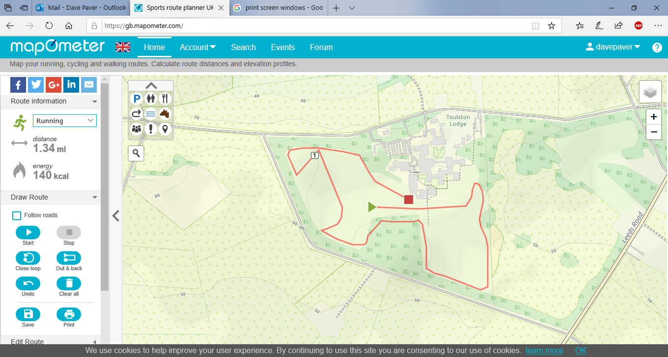
parking
girls
boys
I&S G
H
G
F

Car Park
K

J
Astro
Pitch

C
Short Cut

D

B
E

A

Athletics
Track

Link to next lap
Finish
Start

